REgister NOw for the

*Midwest* *Speed Trials*

May 18th Hawkeye Downs May 19 Prairie High School

1. FIll In and Email barry wilson (bwilson@csrchools) The attached Registration form for your team
2. Mail the $50 entry fee per car to 4545 Wenig Rd. NE Cedar Rapids, Ia 52405 or bring it to the race
3. Bring Each team member’s (pits and Drivers) liability form attached below to the race
4. If you have any further questions, reach out to Barry at [bwilson@crschools.us](mailto:bwilson@crschools.us)

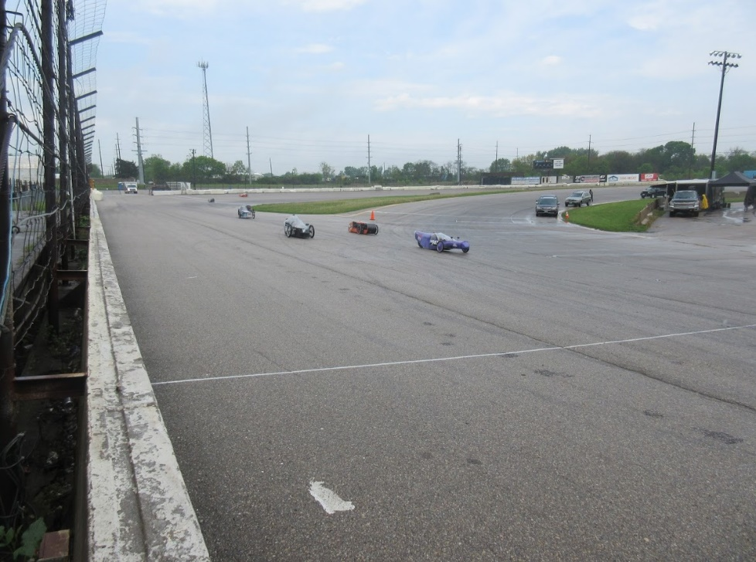

*Hope to see you at the races!*

# Midwest Speed Trials Registration Form

**Contact Information:**

School Name: ________________________

Mailing Address: _______________________________

Director’s Name: ________________

Contact Telephone #: ____________________

Email: ___________________

**Team Information:**

Car Number(s) Driver Names:

*\*Total number of all who will be participating from your team:* __________

List ALL participants who will be in the pits:

**Things to bring with you to the event**

Completed Iowa Electrathon waiver forms for each participant who will be in the pits.

Entry Fee $50.00 Per car

Everything else that you will need will be in your check in packet